Session 5 Homework

Code For Everyone JavaScript

|  |  |
| --- | --- |
|  | **Finish** |

Complete all of your Lab exercise and **submit all of them as usual** (both parts done in class and at home)

|  |  |
| --- | --- |
|  | **Study** |

1. Learn about HTML by

* Watch [Freecodecamp How to make super simple website](https://www.youtube.com/watch?v=PlxWf493en4)

or

* Watch [MindX - C4EJS - HTML](https://drive.google.com/drive/folders/1c8z_54BzNR8uPZIh7PdlaprDfJe4WFtA?usp=sharing)

or

* Read [MindX - C4EJS - HTML Chapter](https://github.com/edtechkidsvn/c4ejs-student-book/blob/master/html/html.md)

or

* Read [W3School HTML](https://www.w3schools.com/html/) or [MDN HTML tutorial](https://developer.mozilla.org/en-US/docs/Learn/HTML)

2. Learn css:

* <https://github.com/edtechkidsvn/c4ejs-student-book/blob/master/css/css-part1.md>
* <https://github.com/edtechkidsvn/c4ejs-student-book/blob/master/css/css-part2.md>
* <https://www.w3schools.com/css/default.asp>

### 3. Learn HTML & CSS. Answer the following questions

### **I. HTML**

[1. HTML là gì](https://thachpham.com/web-development/html-css/html-la-gi-va-vi-sao-no-quan-trong.html)

[2. Tao 1 file HTML](https://thachpham.com/web-development/html-css/soan-thao-van-ban-html-dau-tien.html)

[3. Cấu trúc File HTML](https://thachpham.com/web-development/html-css/cau-truc-tai-lieu-web-html.html)

[4. Các thẻ cơ bản](https://thachpham.com/web-development/html-css/cac-the-khai-bao-thong-tin-web-html-co-ban.html)

[5. Các thẻ định dạng chữ viết và văn bản](https://thachpham.com/web-development/html-css/cac-the-dinh-dang-chu-viet-va-van-ban-html.html)

[6. Tạo danh sách trong file HTML](https://thachpham.com/web-development/html-css/tao-danh-sach-html.html)

[7. Tạo thẻ liên kết và liên kết Neo](https://thachpham.com/web-development/html-css/the-tao-lien-ket-va-lien-ket-neo.html)

[8. Chèn tập tin kỹ thuật số vào file HTML](https://thachpham.com/web-development/html-css/chen-tap-tin-ky-thuat-so-vao-tai-lieu-html.html)

[9. Trình bày văn bản dạng bảng](https://hocwebchuan.com/reference/tag/tag_table.php)

[10. Tạo form nhập liệu](https://thachpham.com/web-development/html-css/tao-form-nhap-lieu.html)

### **II. CSS**

[1. CSS là gì](https://thachpham.com/web-development/html-css/css-la-gi-va-vai-tro.html)

[2. Nhúng CSS vào website](https://thachpham.com/web-development/html-css/them-css-vao-website.html)

[3. Vùng chọn cơ bản (Selector)](https://thachpham.com/web-development/html-css/vung-chon-css-co-ban.html)

[4. Đơn vị đo lường trong CSS](https://thachpham.com/web-development/html-css/cac-don-vi-do-luong-trong-css.html)

[5. Các thuộc tính văn bản](https://thachpham.com/web-development/html-css/cac-thuoc-tinh-cho-van-ban.html)

[6. Font chữ trong văn bản](https://thachpham.com/web-development/html-css/trang-tri-font-chu-cho-van-ban.html)

[7. Block và Inline trong CSS](https://thachpham.com/web-development/html-css/phan-tu-block-va-inline.html)

[8. Div và tạo bố cục trên website](https://thachpham.com/web-development/html-css/the-div-va-tao-bo-cuc-tren-website.html)

[9. Box Model và các thuộc tính](https://thachpham.com/web-development/html-css/css-box-model-va-cac-thuoc-tinh.html)

[10. Các thuộc tính điều chỉnh kích thước](https://thachpham.com/web-development/html-css/thuoc-tinh-tuy-chinh-kich-thuoc-css.html)

[11. Tìm hiểu box-sizing](https://thachpham.com/web-development/html-css/hoc-css-tim-hieu-box-sizing.html)

[12. Màu nền và Ảnh nền (background)](https://thachpham.com/web-development/html-css/mau-nen-va-anh-nen-background.html)

[13. Chia cột với float và clear float](https://thachpham.com/web-development/html-css/chia-cot-voi-float-va-clear-float.html)

[14. Reset CSS là gì](https://thachpham.com/web-development/html-css/reset-css-la-gi-va-vi-sao-nen-reset-css.html)

[15. Tùy biến hiển thị danh sách (List)](https://thachpham.com/web-development/html-css/tuy-bien-danh-sach-list-voi-css.html)

[16. Tùy biến loại phần tử với “display”](https://thachpham.com/web-development/html-css/tuy-bien-loai-phan-tu-voi-display-trong-css.html)

[17. Position và Absolute – Relative](https://thachpham.com/web-development/html-css/position-absolute-va-relative-trong-css.html)

[18. Pseudo Class đơn giản](https://thachpham.com/web-development/html-css/pseudo-class-don-gian-trong-css.html)

[19. Kỹ thuật tạo Menu Ngang cơ bản](https://thachpham.com/web-development/html-css/ky-thuat-tao-menu-ngang-css.html)

[20. Kỹ thuật tạo menu dọc cơ bản](https://thachpham.com/web-development/html-css/tao-menu-doc-co-ban.html)

[21. Thực hành tạo layout đơn giản](https://thachpham.com/web-development/html-css/thuc-hanh-tao-layout-css-don-gian.html)

[22. CSS Framework là gì và cách sử dụng](https://thachpham.com/web-development/html-css/css-framework-la-gi-va-cach-su-dung.html)

[23. Tạo chuyển động với transition](https://thachpham.com/web-development/html-css/hieu-ung-chuyen-dong-css-voi-transition.html)

[24. Thay đổi hình dạng với transform và transform-origin](https://thachpham.com/web-development/html-css/transform-va-transform-origin-trong-css.html)

4. Create a personal CV like the following [template](https://huudinh.github.io/homework/Section-5/hwork-2/)

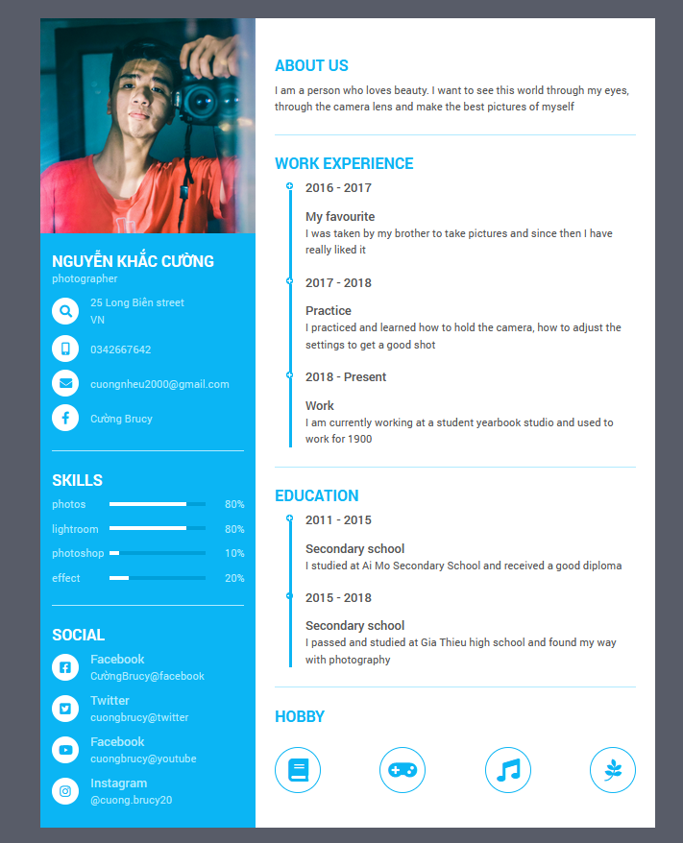

|  |  |
| --- | --- |
|  | **Tools** |

1. You can compose an HTML documents or emails without knowing a lot of its syntax using html tools. Visit [HTML5 Editor](https://html5-editor.net/) to compose an email, a love letter, even formal meeting minutes and see the final HTML result. Submit your screenshots to demonstrate your practice